ISE-2
Name: Atharva Dharmendra Jagtap Dept: CSE Roll no. 10937

Subject: Analysis of Algorithms
Activity Type: Practical Coding & Conceptual Analysis
Total Marks: 20
Target Group: Students who have not appeared for the NPTEL exam
Objective:
To apply algorithmic thinking to solve problems beyond the classroom syllabus, encouraging
independent exploration and deeper understanding.
Topics for Exploration

Students must solve four problems, one from each of the following categories:
1. Dynamic Programming
2. Backtracking
3. Branch and Bound
4. String Matching Algorithms

- String Matching
5. Longest Palindromic Substring
Level: Medium
Given a string s, return the longest palindromic substring in s.

Example 1:
Input: s = "babad"
Output: "bab"
Explanation: "aba" is also a valid answer.
Example 2:
Input: s = "cbbd"
Output: "bb"

Constraints:
- 1 <= s.length <= 1000
- s consist of only digits and English letters.

Code:
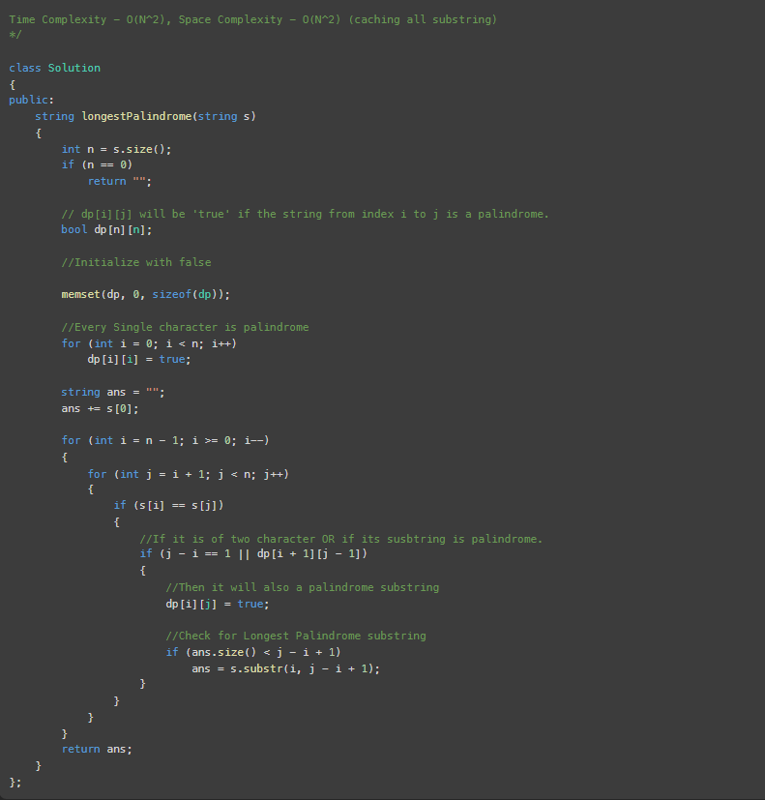

Submission:
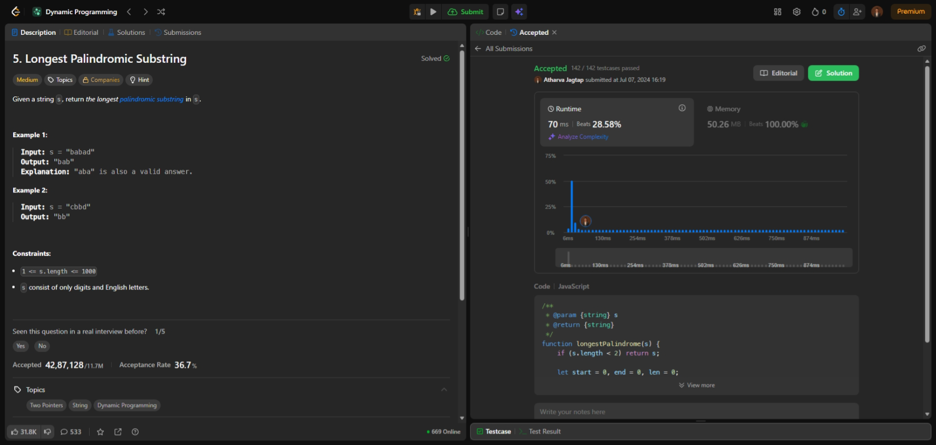

- Dynamic Programming
124. Binary Tree Maximum Path Sum
Level: Hard
A path in a binary tree is a sequence of nodes where each pair of adjacent nodes in the sequence has an edge connecting them. A node can only appear in the sequence at most once. Note that the path does not need to pass through the root.
The path sum of a path is the sum of the node's values in the path.
Given the root of a binary tree, return the maximum path sum of any non-empty path.

Example 1:
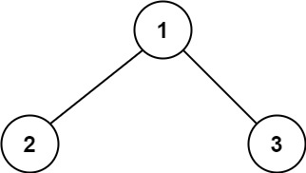
Input: root = [1,2,3]
Output: 6
Explanation: The optimal path is 2 -> 1 -> 3 with a path sum of 2 + 1 + 3 = 6.
Example 2:
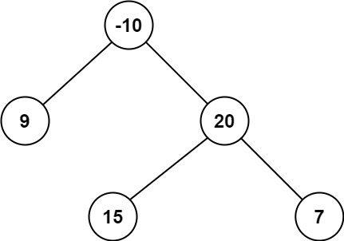
Input: root = [-10,9,20,null,null,15,7]
Output: 42
Explanation: The optimal path is 15 -> 20 -> 7 with a path sum of 15 + 20 + 7 = 42.

Constraints:
- The number of nodes in the tree is in the range [1, 3 * 10⁴].
- -1000 <= Node.val <= 1000
Code:
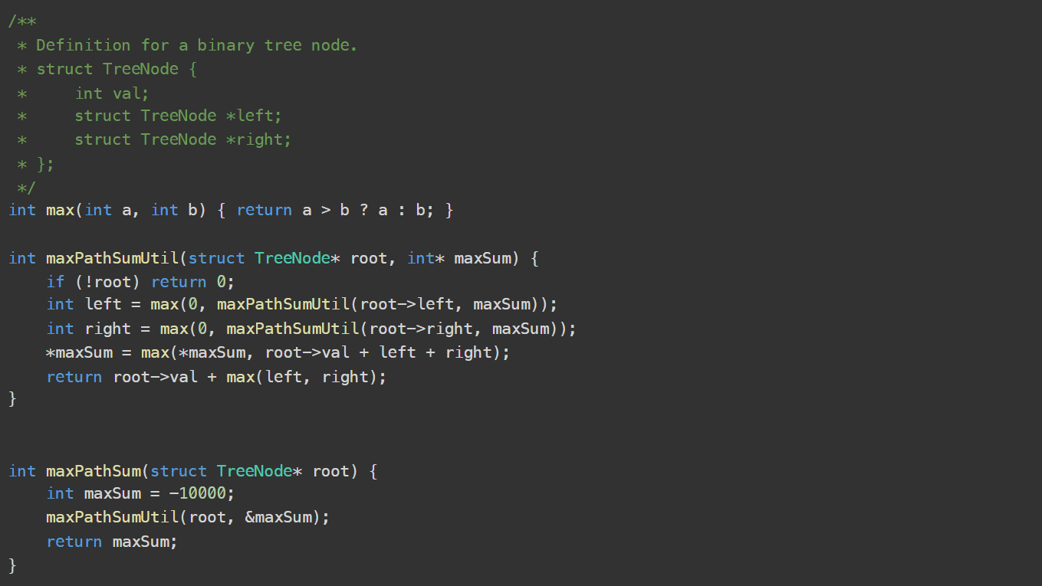
Submission:
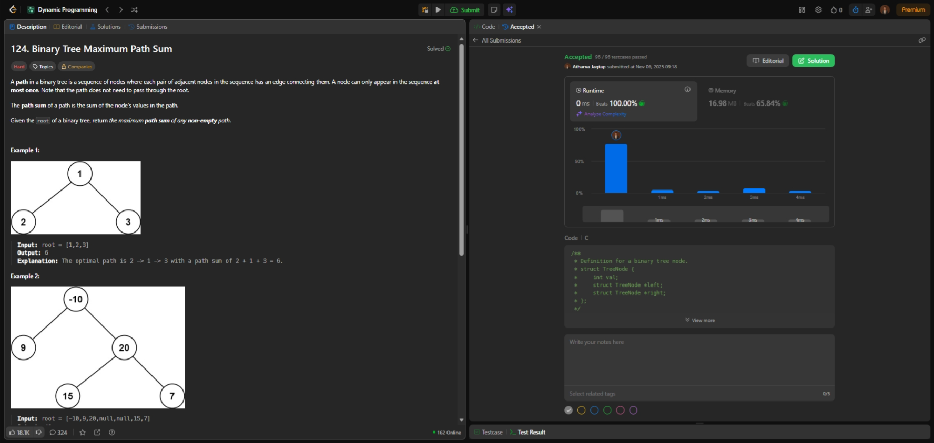
- Backtracking
491. Non-decreasing Subsequences
Level: Medium
Given an integer array nums, return all the different possible non-decreasing subsequences of the given array with at least two elements. You may return the answer in any order.

Example 1:
Input: nums = [4,6,7,7]
Output: [[4,6],[4,6,7],[4,6,7,7],[4,7],[4,7,7],[6,7],[6,7,7],[7,7]]
Example 2:
Input: nums = [4,4,3,2,1]
Output: [[4,4]]

Constraints:
- 1 <= nums.length <= 15
- -100 <= nums[i] <= 100
Topics:
- Array
- Hash Table
- Backtracking
- Bit Manipulation

Submission: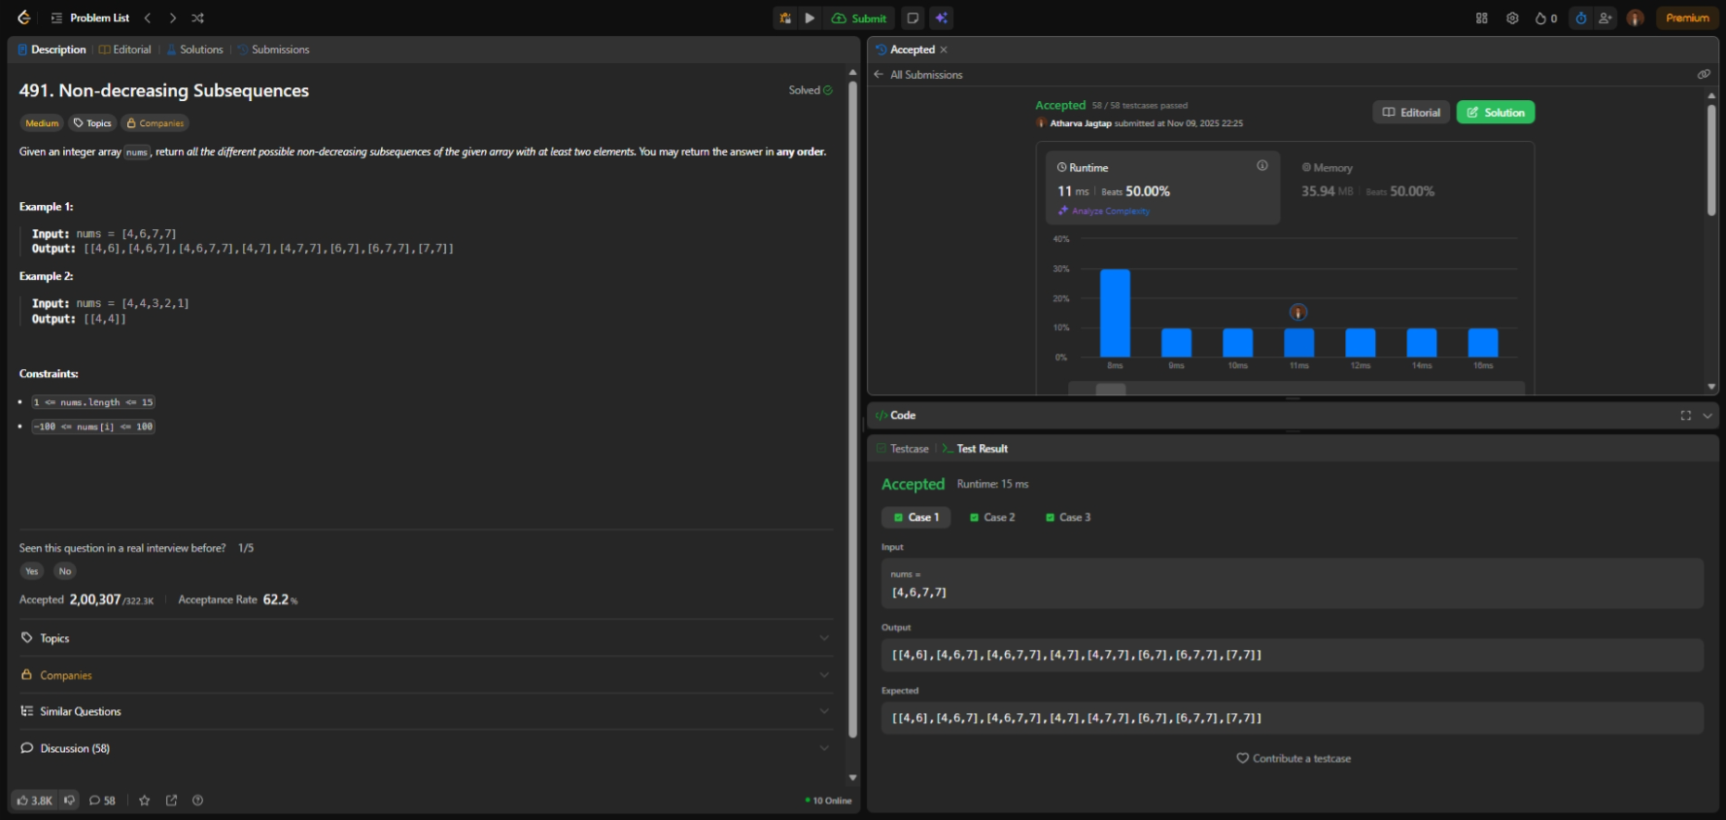

Code:
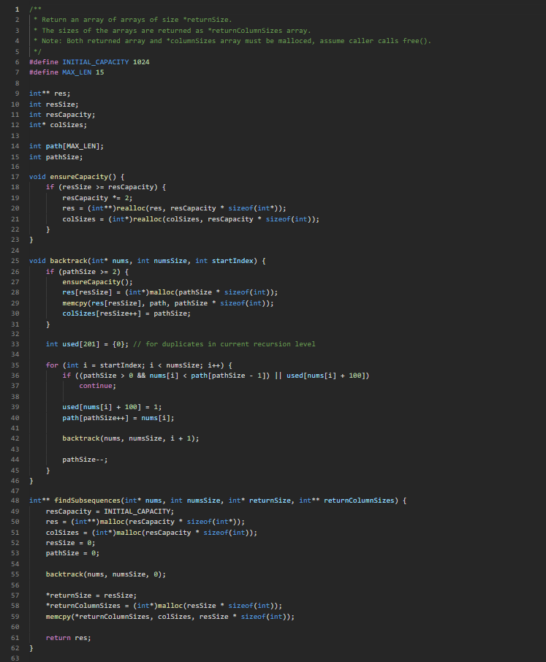

- Branch and Bound
2959. Number of Possible Sets of Closing Branches
Level: Hard
There is a company with n branches across the country, some of which are connected by roads. Initially, all branches are reachable from each other by traveling some roads.
The company has realized that they are spending an excessive amount of time traveling between their branches. As a result, they have decided to close down some of these branches (possibly none). However, they want to ensure that the remaining branches have a distance of at most maxDistance from each other.

The distance between two branches is the minimum total traveled length needed to reach one branch from another.

You are given integers n, maxDistance, and a 0-indexed 2D array roads,
where roads[i] = [u_{i}, v_{i}, w_{i}] represents the undirected road between branches u_{i} and v_{i} with length w_{i}.

Return the number of possible sets of closing branches, so that any branch has a distance of at most maxDistance from any other.

Note that, after closing a branch, the company will no longer have access to any roads connected to it.

Note that, multiple roads are allowed.

Example 1:

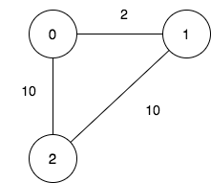

Input: n = 3, maxDistance = 5, roads = [[0,1,2],[1,2,10],[0,2,10]]
Output: 5
Explanation: The possible sets of closing branches are:
- The set [2], after closing, active branches are [0,1] and they are reachable to each other within distance 2.
- The set [0,1], after closing, the active branch is [2].
- The set [1,2], after closing, the active branch is [0].
- The set [0,2], after closing, the active branch is [1].
- The set [0,1,2], after closing, there are no active branches.
It can be proven, that there are only 5 possible sets of closing branches.

Example 2:
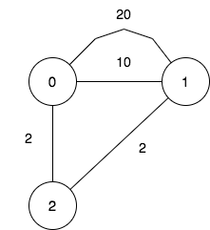

Input: n = 3, maxDistance = 5, roads = [[0,1,20],[0,1,10],[1,2,2],[0,2,2]]
Output: 7
Explanation: The possible sets of closing branches are:
- The set [], after closing, active branches are [0,1,2] and they are reachable to each other within distance 4.
- The set [0], after closing, active branches are [1,2] and they are reachable to each other within distance 2.
- The set [1], after closing, active branches are [0,2] and they are reachable to each other within distance 2.
- The set [0,1], after closing, the active branch is [2].
- The set [1,2], after closing, the active branch is [0].
- The set [0,2], after closing, the active branch is [1].
- The set [0,1,2], after closing, there are no active branches.
It can be proven, that there are only 7 possible sets of closing branches.

Example 3:

Input: n = 1, maxDistance = 10, roads = []
Output: 2
Explanation: The possible sets of closing branches are:
- The set [], after closing, the active branch is [0].
- The set [0], after closing, there are no active branches.
It can be proven, that there are only 2 possible sets of closing branches.

Constraints:
- 1 <= n <= 10
- 1 <= maxDistance <= 10⁵
- 0 <= roads.length <= 1000
- roads[i].length == 3
- 0 <= u_{i}, v_{i} <= n - 1
- u_{i} != v_{i}
- 1 <= w_{i} <= 1000
- All branches are reachable from each other by traveling some roads.

Code:
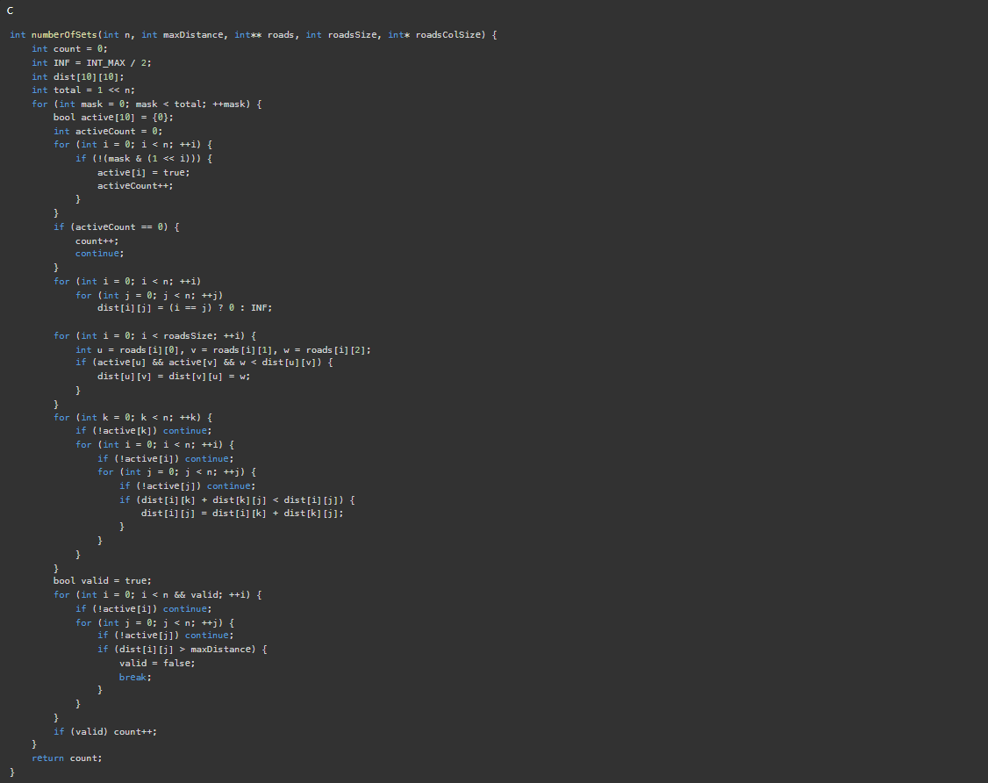

Submission:
